

POLICY COMPASS
Tariffs, Uncertainty, and Recession Fears: Inside the IMF’s Latest Forecast
By
Lāsma Kokina


20 May 2025

Lāsma Kokina
Tariffs, Uncertainty, and Recession Fears: Inside the IMF’s Latest Forecast
20 May 2025
Table of Contents
Executive Summary ................................................................................................................... Page | 3
1. Forecasting Amid Volatility: A Look at the IMF’s Projections ...................................................... | 4
1.1 IMF World Economic Outlook: Key points........................................................................................... | 4
1.2 US Forecasts .......................................................................................................................................... | 4
1.3 Global Financial Markets ....................................................................................................................... | 5
APPENDIX ............................................................................................................................................ | 7
NOTES .......……………………………………………………………………………………………………………………………………….. | 8


Rosa & Roubini Associates Ltd is a private limited company registered in England and Wales (Registration number: 10975116) with registered office at 118 Pall Mall, St. James’s, London SW1Y 5ED, United Kingdom.
For information about Rosa&Roubini Associates, please send an email to info@rosa-roubini-associates.com or call +44 (0)20 7101 0718.
Analyst Certification: I, Lāsma Kokina, hereby certify that all the views expressed in this report reflect my personal opinion, which has not been influenced by considerations of Rosa & Roubini Associates’ business, nor by personal or client relationships. I also certify that no part of my compensation was, is or will be, directly or indirectly, related to the views expressed in this report.
Disclaimer: All material presented in this report is provided by Rosa & Roubini Associates-Limited for informational purposes only and is not to be used or considered as an offer or a solicitation to sell or to buy, or subscribe for securities, investment products or other financial instruments. Rosa & Roubini Associates Limited does not conduct “investment research” as defined in the FCA Conduct of Business Sourcebook (COBS) section 12 nor does it provide “advice about securities” as defined in the Regulation of Investment Advisors by the U.S. SEC. Rosa & Roubini Associates Limited is not regulated by the FCA, SEC or by any other regulatory body. Nothing in this report shall be deemed to constitute financial or other professional advice in any way, and under no circumstances shall we be liable for any direct or indirect losses, costs or expenses nor for any loss of profit that results from the content of this report or any material in it or website links or references embedded within it. The price and value of financial instruments, securities and investment products referred to in this research and the income from them may fluctuate. Past performance and forecasts should not be treated as a reliable guide of future performance or results; future returns are not guaranteed; and a loss of original capital may occur. This research is based on current public information that Rosa & Roubini Associates considers reliable, but we do not represent it is accurate or complete, and it should not be relied on as such. Rosa & Roubini Associates, its contributors, partners and employees make no representation about the completeness or accuracy of the data, calculations, information or opinions contained in this report. Rosa & Roubini Associates has an internal policy designed to minimize the risk of receiving or misusing confidential or potentially material non-public information. We seek to update our research as appropriate, but the large majority of reports are published at irregular intervals as appropriate in the author's judgment. The information, opinions, estimates and forecasts contained herein are as of the date hereof and may be changed without prior notification. This research is for our clients only and is disseminated and available to all clients simultaneously through electronic publication. Rosa & Roubini Associates is not responsible for the redistribution of our research by third party aggregators. This report is not directed to you if Rosa & Roubini Associates is barred from doing so in your jurisdiction. This report and its content cannot be copied, redistributed or reproduced in part or whole without Rosa & Roubini Associates’ written permission.
Lāsma Kokina
Tariffs, Uncertainty, and Recession Fears: Inside the IMF’s Latest Forecast
20 May 2025
Executive Summary
⦠ | The IMF significantly downgraded growth forecasts for major economies, with the UK receiving the sharpest revision among European countries.
⦠ | Global GDP is projected to grow by 2.8% in 2025 and 3.0% in 2026, reflecting increased global uncertainty and tariff-driven challenges. The US growth forecast was lowered to 1.8%, driven by rising tariffs, policy uncertainty, and weakening consumer demand.
⦠ | Despite a 90-day pause on some US tariffs, the economic damage from the escalation in US-China trade tensions remains considerable. A temporary easing in tensions occurred in May with a US-China deal reducing tariffs for 90 days, but longer-term uncertainty persists.
⦠ | The IMF flagged risks in the US debt market, particularly involving hedge fund strategies like the basis trade, which rely on heavy borrowing.
⦠ | Financial market volatility is rising, with concurrent drops in the US dollar, stocks, and bonds, though capital outflows remain limited so far.
⦠ | While US financial markets still dominate globally, the IMF urged readiness to intervene in case of instability and emphasised access to central bank support.
⦠ | Global trade uncertainty has surged to levels seven times higher than in October 2024, surpassing even the pandemic peak.
⦠ | The IMF warned that excessive leverage, high asset valuations, and growing national debt levels could amplify market stress and investor anxiety.
Key Picture: IMF Revisions (22 April): Growth revised down significantly, and Inflation revised up slightly.
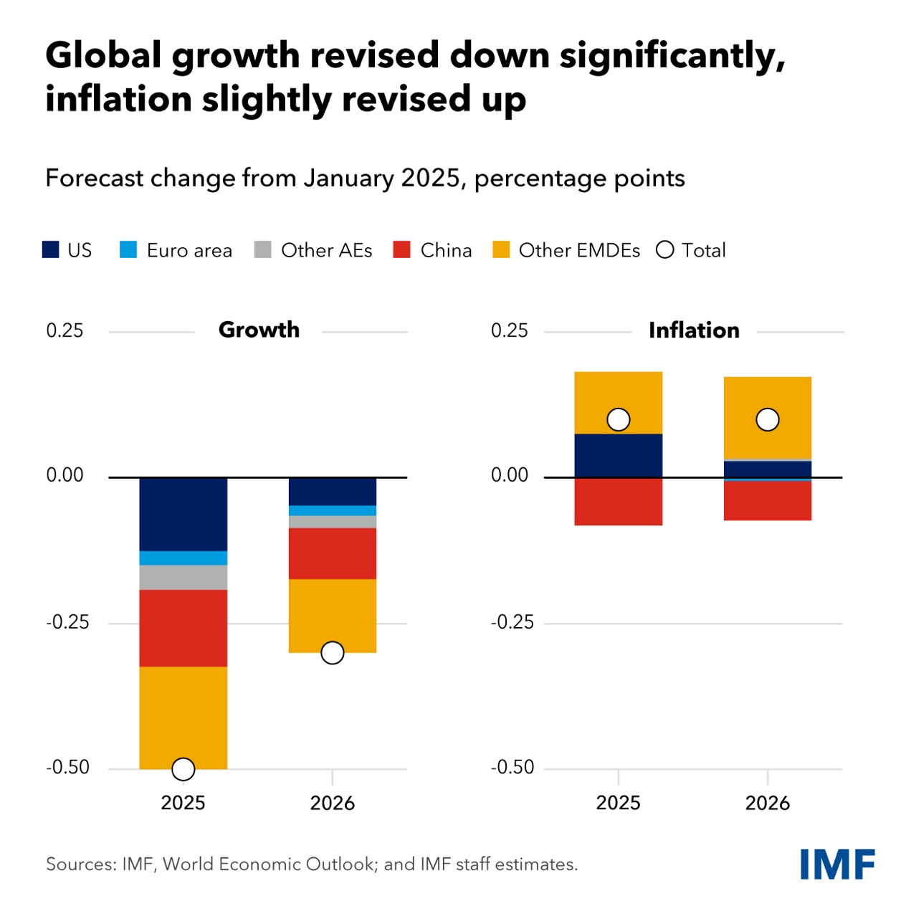
Source: IMF World Economic Outlook and IMF Staff Estimates (22 April 2025), percentage points.
Section 1. Forecasting Amid Volatility: A Look at the IMF Projections
1.1 IMF World Economic Outlook: Key Points
In April, the International Monetary Fund (IMF) released its World Economic Outlook, significantly lowering its growth projections for the United States, China, and the majority of other countries, including Canada, Japan, the UK, Germany, France and Italy, attributing the downgrade to the effects of US tariffs. The IMF delivered the steepest downgrade to the UK’s 2025 economic growth forecast among all major European economies, also reporting that inflation in the UK is expected to be higher this year than it had projected in January, and higher than in any other G7 nation. The IMF also cautioned that escalating trade tensions are likely to further dampen global economic growth.
Concerning GDP, the IMF report projects global GDP growth of 2.8% in 2025 and 3.0% in 2026 (see Appendix A). In the euro area, economic growth is expected to reach 0.8% in 2025 and 1.2% in 2026. These projections mark a significant downward revision from the IMF’s estimates released only three months earlier. A central factor underlying the latest report and its more cautious outlook is the markedly increased level of global uncertainty compared to just a short time ago.
The forecasts were made based on tariff conditions as of April 4, before the Trump administration’s 90-day suspension of proposed reciprocal tariffs. However, even if the pause is prolonged, the impact on global growth would likely remain the same due to the steep and damaging escalation in tariffs between the US and China.
The IMF cautioned that global financial stability faces growing risks, economic growth is likely to slow due to the highest tariffs seen in a century, and maintaining the credibility of central banks remains crucial.
According to Pierre-Olivier Gourinchas, the IMF’s chief economist, the world is transitioning into a new phase as the global economic system that has shaped the past 80 years undergoes significant changes. He also emphasised that, in addition to the sharp rise in tariffs, policy uncertainty plays a major role in shaping the IMF’s outlook and, if it continues, could severely hinder global economic growth.
The IMF is not expected to go so far as to predict that the US president’s policies will lead to a full-scale global recession. However, they acknowledged that the likelihood has increased, from 17% in October to 30%. While markets have experienced turbulence and the US dollar has weakened alongside falling bond and stock prices, the IMF noted that they have not yet observed clear signs of financial market stress.
1.2 US Forecasts
The IMF has revised its US growth forecast down to 1.8%, a drop of 0.9 percentage points from its January projection. While tariffs account for less than half of that decline, the economy had already been losing momentum before the trade tensions escalated in April. The rise in tariffs is expected to add to inflationary pressures in the US, which is emerging from a period of elevated inflation. The significant downgrade to the US economic growth forecast this year is attributed the revision primarily to the uncertainty created by trade tariffs.
In addition, the IMF attributed the downward revision of the US growth forecast to increased policy uncertainty, ongoing trade tensions, and weaker-than-anticipated consumer spending. It also warned that tariffs are likely to dampen growth in 2026. Additionally, the IMF now estimates a 40% chance of a US recession occurring this year, a notable increase from the 25% probability it projected in October of the previous year.
Indeed, the US economy continues to face considerable uncertainty in the wake of the significant trade policy actions taken in early April. However, there has been a noticeable reduction in tensions since then. A key step toward restoring a sense of normalcy occurred on May 12, when the US and China announced an agreement to lower tariffs by a combined 115 percentage points for a minimum of 90 days. According to the terms of the deal, Chinese exports to the US will now be subject to a 30% tariff, while US exports to China will face a 10% tariff.
The IMF emphasised that its forecasts are subject to significant uncertainty due to numerous unpredictable factors. While the Trump administration has postponed the implementation of certain tariffs and is actively pursuing trade agreements with multiple countries to reduce the reciprocal tariffs introduced on April 2, uncertainty remains high. The US and China seem to be entrenched in a prolonged economic dispute that may continue to weigh on global growth until a resolution is reached. Although Trump has indicated a willingness to modify tariffs in response to severe market volatility, he has not suggested any intention to reverse his broader tariff strategy.
Additionally, the IMF has also raised concerns about the sharp rise in US government borrowing, particularly as yields on 10-year and 30-year Treasury bonds have spiked. Tobias Adrian, who leads the IMF’s monetary and capital markets department, noted the rare occurrence of the US dollar, stocks, and bonds all weakening at the same time. While it's still unclear how long this trend might persist, he said that capital outflows from US assets remain relatively small when compared to the significant inflows over recent years.
Although the IMF did not explicitly name the US, it highlighted a specific risk concentrated in the $29 trillion US government debt market: the basis trade. This strategy, commonly used by hedge funds, involves significant borrowing to profit from slight price discrepancies between government bonds and corresponding futures contracts. To address these growing risks, the IMF issued several policy recommendations. It emphasised the need for authorities to be ready to intervene to prevent market dysfunction and called for financial institutions to have reliable access to central bank support mechanisms in the event of a crisis.
Even with questions emerging about the safe-haven status of the US dollar and Treasury securities, the IMF emphasised the ongoing strength of US financial markets.
The dollar continues to make up 60% of global foreign exchange reserves, and the US now accounts for over half of global market capitalisation - a significant rise from 2010. Although recent market volatility has been notable, IMF officials said financial markets are still operating in an orderly manner. However, they are closely monitoring potential stress points, particularly in the pricing of long-term Treasury debt, cross-currency lending, and the short-term repo market.
1.3 Global Financial Markets
In addition to the negative impact on individual economies, the IMF cautioned that this new period of heightened uncertainty poses a broader risk of disruption to global financial markets. The IMF warned that global financial stability risks have risen sharply over the past two months due to surging policy uncertainty, coinciding with historically high valuations in both stock and bond markets.
The IMF’s world trade uncertainty index has surged to a level seven times higher than it was in October 2024, exceeding even the peak reached during the pandemic. This heightened uncertainty poses a more serious threat to the global economy than the imposition of high but clearly defined tariffs. When tariffs are predictable, businesses can adapt their supply chains, and consumers can seek alternatives. While such adjustments carry economic costs, they allow for planning and risk management.
In contrast, the current environment offers no such clarity. Companies are unable to assess the potential impact of tariffs, as their levels appear to change unpredictably. For instance, a US firm might purchase goods from the EU, assuming a 10% tariff, only to face a sudden increase to 100% upon arrival, triggered not by formal policy, but by an offhand remark from a presidential advisor. Reports suggest that key tariff decisions have been made with minimal coordination, and in at least one case, halted only due to the temporary absence of a key advisor. This extreme policy volatility leaves both consumers and businesses uncertain, making inaction the most rational, if economically paralysing, response.
As such, potential slowdown in economic growth caused by tariffs, along with increased policy uncertainty and tighter financial conditions, is raising concerns about the strength and stability of global financial markets. The IMF pointed to three key risk areas. First, it noted that stock and corporate bond prices remain elevated despite recent market declines. Second, it warned that hedge funds and other nonbank financial entities have taken on more leverage, which could amplify market selloffs. Lastly, the IMF highlighted that many countries have accumulated high levels of debt, leading to growing investor worries about whether this borrowing is sustainable.

APPENDIX
A) Change In Real GDP Estimates
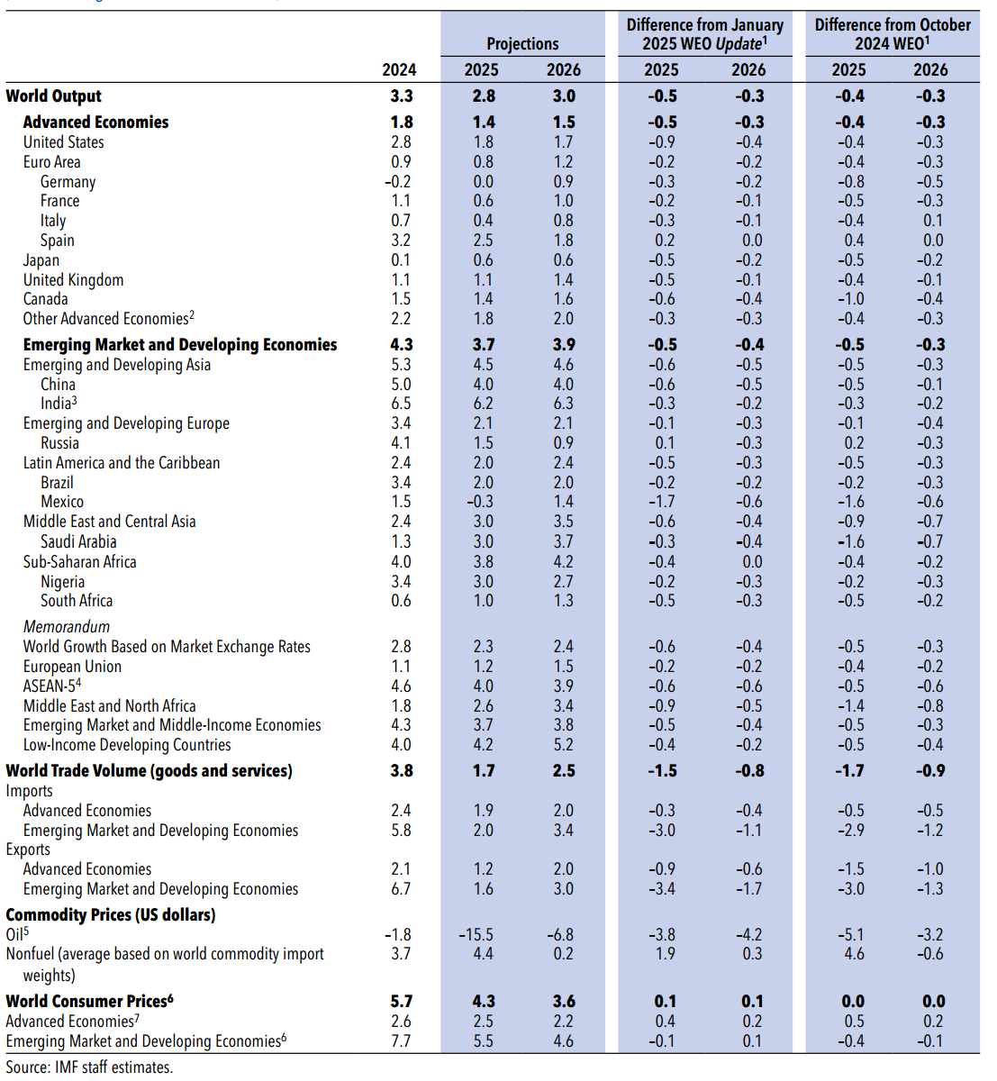

B) Inflation Estimates
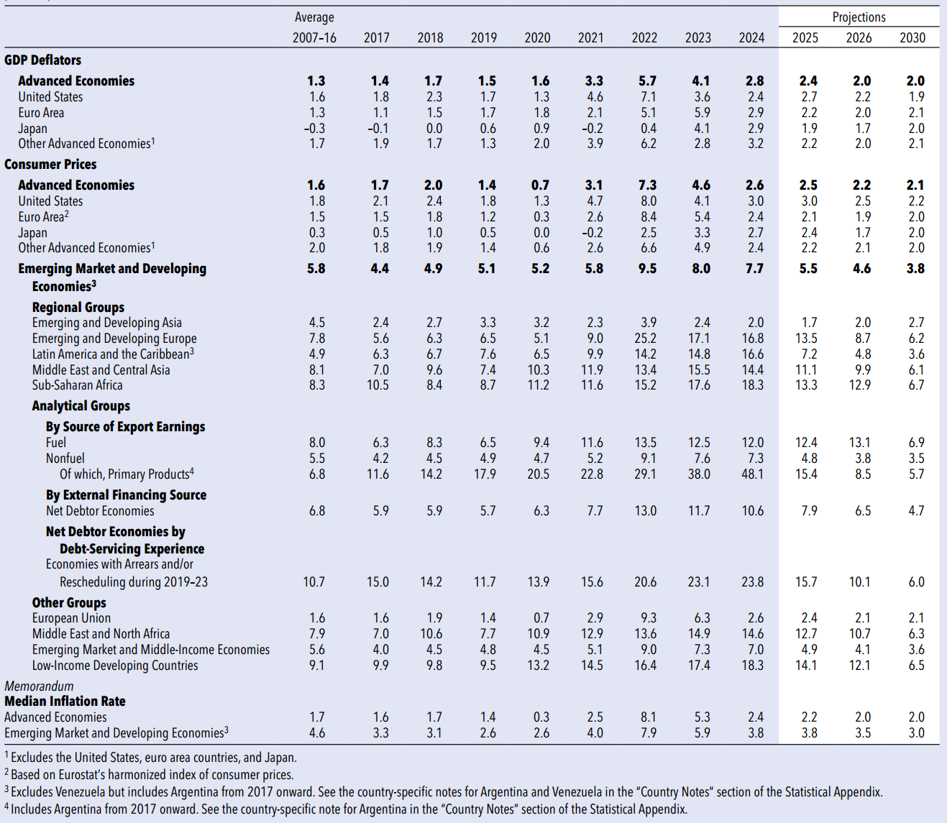

NOTES

Andrea Shalal, “IMF cuts growth forecasts for most countries in wake of century-high US tariffs”, Reuters, accessed 17 May 2025, https://www.reuters.com/business/imf-cuts-growth-forecasts-most-countries-wake-century-high-us-tariffs-2025-04-22/.
Imogen James, “Global growth forecast slashed by IMF over tariff impact”, BBC, accessed 18 May 2025, https://www.bbc.co.uk/news/live/c4g2l654dket.
Andrea Shalal, “IMF cuts growth forecasts for most countries in wake of century-high US tariffs”, Reuters.
William Schomberg, “IMF chops UK growth forecast as Trump tariffs hit global economy”, Reuters, accessed 18 May 2025, https://www.reuters.com/sustainability/sustainable-finance-reporting/imf-chops-uk-growth-forecast-trump-tariffs-hit-global-economy-2025-04-22/.
Andrea Shalal, “IMF cuts growth forecasts for most countries in wake of century-high US tariffs”, Reuters.
Sergi Basco, “IMF World Economic Outlook: economic uncertainty is now higher than it ever was during COVID”, The Conversation, accessed 18 May 2025, https://theconversation.com/imf-world-economic-outlook-economic-uncertainty-is-now-higher-than-it-ever-was-during-covid-255055.
Reshma Kapadia and Karishma Vanjani, “IMF Lowers Global Growth Outlook, Stresses Need for Fed Independence”, Barron’s, accessed 17 May 2025, https://www.barrons.com/articles/imf-growth-outlook-financial-stability-fbe2548c.
Ibid.
Claire Jones and Stephanie Stacey, “IMF chief cuts growth forecast over ‘off the charts’ trade uncertainty”, The Financial Times, accessed 17 May 2025, https://www.ft.com/content/6084da8c-73f2-4405-8b66-5aa4066c3db8.
Reshma Kapadia and Karishma Vanjani, “IMF Lowers Global Growth Outlook, Stresses Need for Fed Independence”, Barron’s.
Ibid.
Nick Edser, “Global growth forecast slashed by IMF over tariff impact”, BBC, accessed 18 May 2025, https://www.bbc.co.uk/news/articles/czx415erwkwo.
Ibid.
Aengus Collins, “A step back from the brink for the global economy, and other key economic news to know”, accessed 18 May 2025, https://www.weforum.org/stories/2025/05/step-back-from-brink-for-global-economy-and-other-key-economic-news/.
Alan Rappeport, “Global Growth Expected to Sputter Amid Trade War Fallout Fears”, The New York Times, accessed 18 May 2025, https://www.nytimes.com/2025/04/22/us/politics/imf-world-economic-outlook.html.
Reshma Kapadia and Karishma Vanjani, “IMF Lowers Global Growth Outlook, Stresses Need for Fed Independence”, Barron’s.
Carlo Martuscelli and Johanna Treeck, “IMF: Trump tariffs are crashing world economy, with US worst off”, Politico, accessed 18 May 2025, https://www.politico.eu/article/international-monetary-fund-slash-world-growth-forecast-trade-war/.
Reshma Kapadia and Karishma Vanjani, “IMF Lowers Global Growth Outlook, Stresses Need for Fed Independence”, Barron’s.
Carlo Martuscelli and Johanna Treeck, “IMF: Trump tariffs are crashing world economy, with US worst off”, Politico.
Sergi Basco, “IMF World Economic Outlook: economic uncertainty is now higher than it ever was during COVID”, The Conversation.
Ibid.
Reshma Kapadia and Karishma Vanjani, “IMF Lowers Global Growth Outlook, Stresses Need for Fed Independence”, Barron’s.

